Roadmap RC car with AI

Objectives:
1.Autonomous driving capability
2.The driving style is similar to the driver’s driving style( with a ML model)
Reason for 2:to make the driver feel safer because the car drives similarly so the driver AND to eliminate human error
3.To park itself in a designated lateral spot
4.to make the smartest decisions in any difficult situation
Block design:
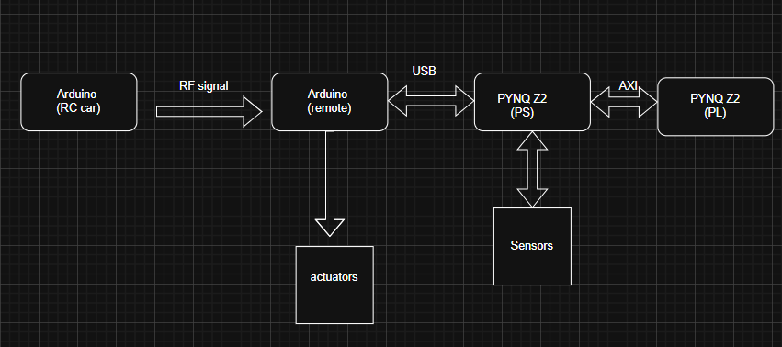
Implementation:
2 and 4.An accurate ML model (a neural network)that learns from the driver(the dataset is made out of many information with the following format( image)).
-custom neural network to run on a DPU
1.A infinite loop (python script) ran by linux in which:
-read a frame from the web camera and the data from the sensors
-provide the frame as input for the ML algorithm
-if there are some constraints,based on the sensor data,such as:
Based on the ultrasonic sensor from the right part of the car,there is an obstacle at distance L<referenceDistance => don’t steer too much to the right =>servoMotorAngle<140 degrees
Idea:servoMotorAngle=L*a+b; Use a linear regression model to find a and b as accurately as possible
-the model gives the speed(or PWM signal voltage) and directions as result
-sends the result to the Arduino uno,and then to the actuators
3. FSM (Finite State Machine): Handles critical sensor data processing (Ultrasonic/Gyroscope)
Will implement both Moore and Mealy to benchmark latency vs. stability (Mealy for speed, Moore for safety).
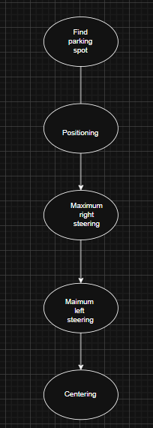
Other uses of the FPGA:
-PL: Future plan to move the Computer Vision preprocessing pipeline to PL for lower latency.
-Linux on PS:gathering the dataset from PL

